**Homework 11.**

**Assigned: 14 November 2017**

**Due: 5:00PM PST, 21 November 2017**

**Instructions: There are ten multiple choice questions. To receive credit, EMAIL your solution by the deadline to** [**tony_statman@yahoo.com**](mailto:tony_statman@yahoo.com) **according to the following instructions:**

* The SUBJECT LINE must be “**GSBA545 HW11 for [Last name, First name] –** “ and then the ten letters corresponding to your answers; so, for example, if your name were John Doe, and you believed the answers were CABEDABCCD, then the subject line of the email must be “**GSBA545 HW11** for **Doe, John - DADABADCAD**”
  + The first seven characters (**GSBA545**) do not have a space between “GSBA” and “545”
  + The ten characters of your answer should have **no spaces in between**
  + If you submit less than 10 letters, it is assumed that the first letter corresponds to your answer to the first question, etc.
* The FIRST LINE of the body of the email should be your last name, your first name, and your student ID
* The SECOND LINE of the body of the email should be five letters, corresponding to the answers to the five questions (make sure your answer consists of five characters)

**For example, a typical email might be**

From: John Doe <john.doe@usc.edu>

To: tony_statman <tony_statman@yahoo.com>

Subject: GSBA545 HW11 for Doe, John - DADABADCAD

DOE, JOHN 123456789  
DADABADCAD

In March 2006, The Economist reported results for number of blades per razor by year of introduction (http://www.economist.com/node/5624861 ). Based on the data in the article,

|  |  |  |
| --- | --- | --- |
| Razor | Year | Blades per Razor |
| Gillette Safety Razor | 1901 | 1 |
| Gillette Trac II | 1971 | 2 |
| Gillette Mach III | 1998 | 3 |
| Schick Quattro | 2003 | 4 |
| Gillette Fusion 5 | 2006 | 5 |

1. The article suggests that a “power law” model might be appropriate. The standard form of a “power law” model is Y =  X; it can be shown (by taking logarithms) that this is equivalent to “ln Y = ln() +  ln(X).” Fit a power law model of the form “ln(# of blades per razor) = b0 + b1 ln(Year)” to the data. Based on this power law model, what year has a predicted value of 6.00 for number of blades per razor?
2. Between 2011 and 2012
3. Between 2020 and 2021
4. Between 2029 and 2030
5. Between 2037 and 2038
6. Between 2072 and 2073
7. For the power law model, which razor was the largest outlier?
8. Gillette Safety Razor
9. Gillette Trac II
10. Gillette Mach III
11. Schick Quattro
12. Gillette Fusion 5
13. An alternative model suggested by the article is a “hyperbolic” model. One “hyperbolic” model is of the form Y =  / (X – ); it can be shown (by taking reciprocals) that the model is equivalent to “1 / Y = –(/) + (1/)X”. Fir a hyperbolic model to the data using the equation “(1 / Blades) = b0 + b1(Year)”; i.e., use “Year” to predict “1/Blades”. Based on this hyperbolic model, what year has a predicted value of 7.00 for number of blades per razor?
14. Between 2011 and 2012
15. Between 2015 and 2016
16. Between 2018 and 2019
17. Between 2021 and 2022
18. Between 2022 and 2023
19. According to the hyperbolic model, the number of blades per razor will go to infinity. In what year does the 95% confidence limit for “1/blades per razor” first include an infinite number of blades per razor?
20. 2021 to 2022
21. 2027 to 2028
22. 2030 to 2031
23. 2038 to 2039
24. 2051 to 2052

In one paper, authors Graham et al. argue that “health is wealth”: that having lower income increases the risk of death (<https://www.ncbi.nlm.nih.gov/pubmed/1410704> ). The authors collected data over several years; for each year, the authors found the inflation-adjusted average income that year, and the age-adjusted average death rate that year. The data that were used have been updated. A plot of the data showed the following

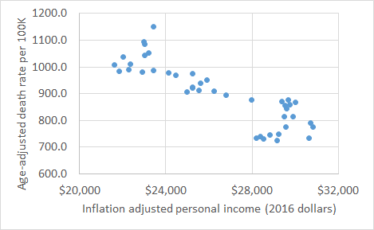

|  |  |
| --- | --- |
| The authors then performed a regression, using personal income to predict age-adjusted death rate, and obtained the following results  5. A skeptic says that these data are like a simple random sample of n=42 (year,death rate) combinations from a population, but that there is no evidence of a relationship in the population. Do the data show a “statistically significant” relationship?   1. Yes, T = 22 2. Yes, T = –11 3. Yes, T = 117 4. No, T = –0.03 5. Yes, T = 58 |  |

6. Based on the calculations by Tax Policy Center (see <http://www.factcheck.org/2017/10/tax-hike-benefit-middle-class/> ) , the GOP tax plan as currently proposed could result in a net increase of $1690 per household. Suppose it is known that, in the population, one data point has a higher inflation-adjusted income than the other data point by $1690; what is a 95% confidence interval for the difference in age-adjusted mortality rates?

1. 95% conf. that the mortality rate in the higher-income data point is 40 to 69 points lower
2. 95% conf. that the mortality rate in the higher-income data point is 45 to 65 points lower
3. 95% conf. that the mortality rate in the higher-income data point is 47 to 63 points lower
4. 95% conf. that the mortality rate in the higher-income data point is 119 points lower to 10 points higher
5. 95% conf. that the mortality rate in the higher-income data point is 813 to 1050 points lower

7. Have the authors proven their hypothesis that “poorer is risker” and that “health is wealth”? In particular, have the authors shown that increasing a person’s income will decrease his or her risk of death, and that decreasing a person’s income will increase his or her risk of death? Choose the best answer.

1. No, because the correlation was not statistically significant.
2. Yes, because the correlation was significant and the results were from a randomized experiment.
3. Yes, because the correlation was significant and the results were from a “natural experiment” (i.e., where the researchers didn’t assign random outcomes, but the X values were “as if” from a randomized experiment)
4. No, because even thought the correlation was significant, this was an observational study, and observational studies may have confounding factors.
5. No, because income and death rate are independent variables.

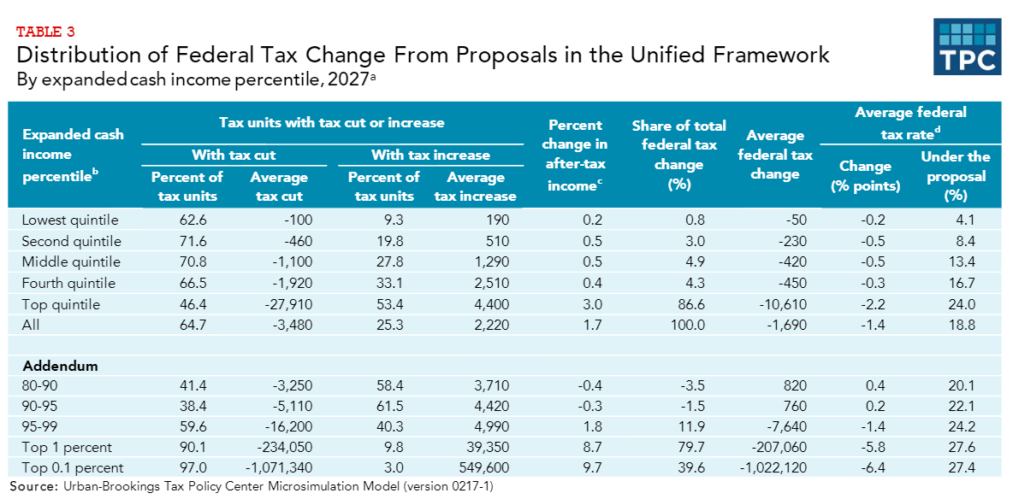

(see <http://www.factcheck.org/2017/10/tax-hike-benefit-middle-class/> )

|  |  |  |  |  |  |  |  |  |  |  |
| --- | --- | --- | --- | --- | --- | --- | --- | --- | --- | --- |
| Year | Income | Death |  | Year | Income | Death |  | Year | Income | Death |
| 1974 | $ 23,426 | 1151.8 |  | 1988 | $ 25,240 | 975.1 |  | 2002 | $ 29,519 | 855.9 |
| 1975 | $ 22,982 | 1094.4 |  | 1989 | $ 25,905 | 949.9 |  | 2003 | $ 29,586 | 843.5 |
| 1976 | $ 23,028 | 1084.1 |  | 1990 | $ 25,626 | 938.0 |  | 2004 | $ 29,496 | 813.7 |
| 1977 | $ 23,202 | 1051.6 |  | 1991 | $ 25,251 | 921.9 |  | 2005 | $ 29,895 | 815.0 |
| 1978 | $ 23,010 | 1043.7 |  | 1992 | $ 24,997 | 905.3 |  | 2006 | $ 30,707 | 791.8 |
| 1979 | $ 22,378 | 1010.6 |  | 1993 | $ 25,242 | 925.8 |  | 2007 | $ 30,821 | 775.3 |
| 1980 | $ 22,038 | 1038.7 |  | 1994 | $ 25,552 | 913.2 |  | 2008 | $ 29,556 | 774.9 |
| 1981 | $ 21,627 | 1007.0 |  | 1995 | $ 26,253 | 909.5 |  | 2009 | $ 29,235 | 749.6 |
| 1982 | $ 21,856 | 984.9 |  | 1996 | $ 26,810 | 893.7 |  | 2010 | $ 28,815 | 747.0 |
| 1983 | $ 22,284 | 990.0 |  | 1997 | $ 27,987 | 877.7 |  | 2011 | $ 28,366 | 741.3 |
| 1984 | $ 22,928 | 982.1 |  | 1998 | $ 29,375 | 870.1 |  | 2012 | $ 28,213 | 732.8 |
| 1985 | $ 23,424 | 987.8 |  | 1999 | $ 29,673 | 875.6 |  | 2013 | $ 28,518 | 731.9 |
| 1986 | $ 24,147 | 978.4 |  | 2000 | $ 29,998 | 869.0 |  | 2014 | $ 29,154 | 724.6 |
| 1987 | $ 24,470 | 969.6 |  | 2001 | $ 29,734 | 858.8 |  | 2015 | $ 30,622 | 733.1 |

Inflation-adjusted personal income from <https://fred.stlouisfed.org/series/MEPAINUSA672N>

Age-adjusted death rates from <https://blogs.cdc.gov/nchs-data-visualization/deaths-in-the-us/>

A company is deciding whether to open up a recreational marijuana dispensary. The company believes that beer consumption is declining in the U.S., and that consumers will seek alternative forms of recreational amusement. Data are available for per capita consumption in the United States (<https://pubs.niaaa.nih.gov/publications/surveillance108/pcyr1970-2015.txt> ) . Summary data are given below:

|  |  |  |  |  |  |  |
| --- | --- | --- | --- | --- | --- | --- |
| Variable | N | Mean | SD | Minimum | Maximum | Corr w/ PERCAP |
| YEAR | 46 | 1993 | 13.42262 | 1970 | 2015 | 1.00000 |
| PERCAP | 46 | 0.96757 | 0.22766 | 0.70670 | 1.36810 | –0.80817 |

“PERCAP” is per capita beer consumption (expressed as gallons of ethanol per person 21 or over in the United States) for a given year.

1. The observed correlation between year and per capita beer consumption was r = –0.80817. Is the correlation “statistically significantly” negative?
2. Not significant, T = –0.73
3. Not significant, T = –1.37
4. Statistically significant, T = –4.83
5. Statistically significant, T = –9.10
6. There is not enough information to determine statistical significance here
7. Fill in the blank: “based on the model, we can be 95% confident that the average per capita beer consumption in 2016 will be less than ___.”

A. 0.585

B. 0.720

C. 0.733

D. 0.937

E. 1.088

1. The company calcualtes it will be profitable as long as per capita beer consumption stays under 0.8 gallons of ethanol per year; the profit function is

The profit function is profit = 60M*(0.8-per capita SPIRITS consumption). Do you recommend the company enter the recreational marijuana industry?

(The $48 million represent fixed costs per year.) Do you recommend the company enter the recreational marijuana industry?

A. Yes, because the company will be profitable from the start, and the trend for spirits consumption is statistically significantly negative.

B. Yes, because although the company will be unprofitable at the start, the trend for spirits consumption is statistically significantly negative and so the company will be profitable within three years.

C. Yes, because the company is profitable at the start, but the trend for spirits consumption is not statistically significant, so the company may be unprofitable after three years.

D. No, because the company is not profitable at the start, and the the trend for spirits consumption is increasing.

E. No, because the relationship between profit and per capita spirits consumption is not a causal relationship.